GitHub project

You should already have access

https://github.com/csurbier/SellTix.git

Your old code design is in SellTixLive directory.

The new project is in Verona directory. It’s using PrimeNg with Verona template.
https://verona.primeng.org/
https://verona.primeng.org/utilities/colors
https://verona.primeng.org/utilities/icons

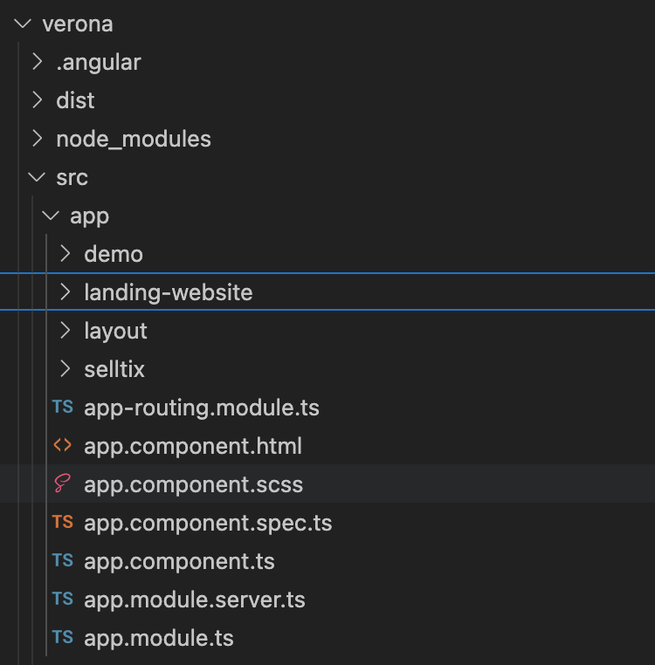

Under app directory, we have :

demo: Verona demo pages. I keep it to check how they do, but we will remove this directory

landing-website: You will implement the new landing page in this directory. I have copy some components from old website, because there contain some text and features, that I will implement with the new design.
Examples:

http://localhost:4200/cgu
http://localhost:4200/privacy

Just ignore these components for now.

layout: This directory is used by Verona template to manage the available layout of the pages. I check with Roger, we can keep this layout (which is different from their figma). So it will be more easy for you. We can discuss about it.

selltix: In this directory we will implement the new dashboard website. I already have started some components.

SellTix landing page

https://www.figma.com/design/ZnVC8rhR9zXhriHzFSQ1DV/Selltix?node-id=33-108&node-type=frame&t=qwQBsUVoN4ePgCpc-0

We have chosen this template (the first one), for our landing page.

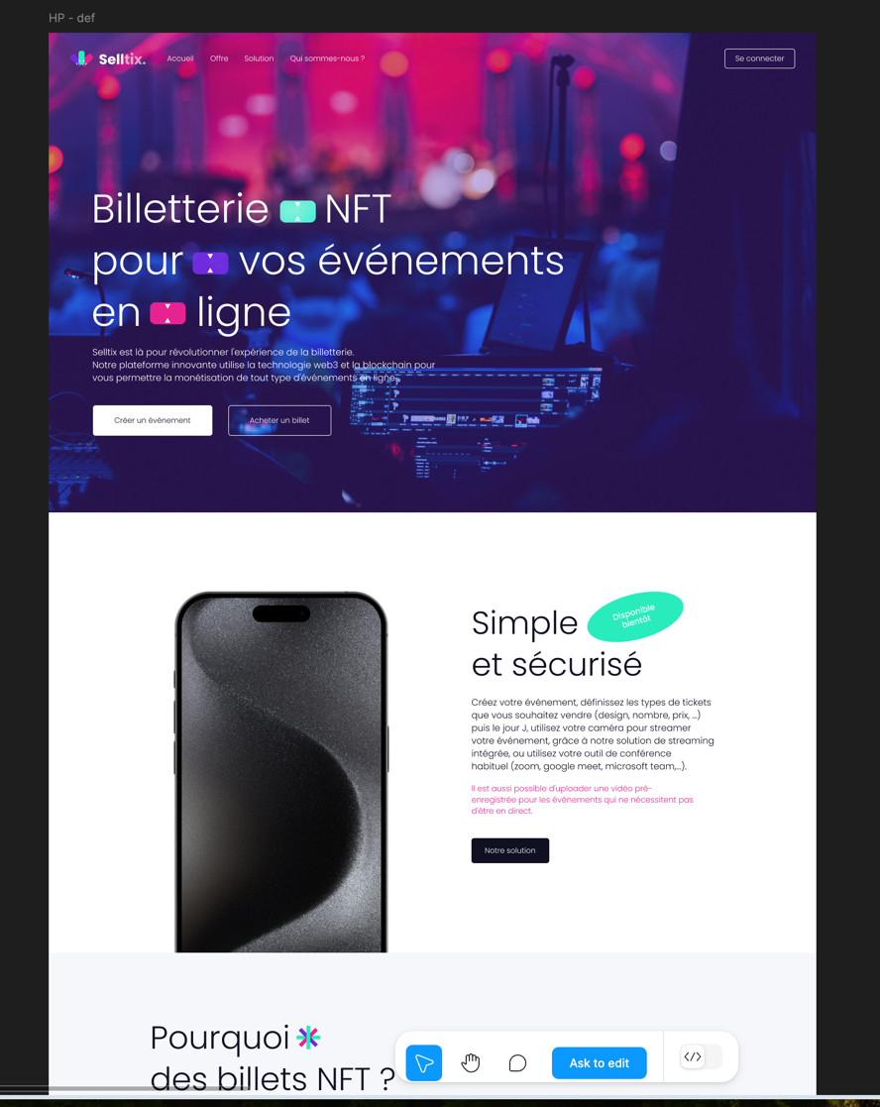

Could you implement it?
Please notice they have added an image of a phone in the first block, but it makes no sense because it’s not a mobile app… We will replace with a screenshot of our dashboard once developed. Meanwhile may be we could used another image like this one, that you can find on figma, template 2.

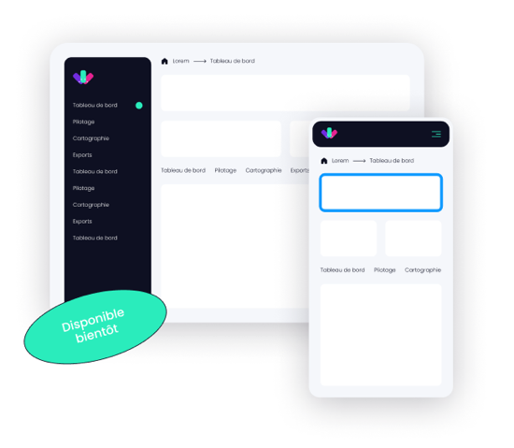
Also for our landing page, they didn’t made a “basic” page (like a blog page) on which I could display some information. As example of what we had on our previous website:

https://www.selltix.live/securite
https://www.selltix.live/paiement-organisateurs
https://www.selltix.live/billetterie-blockchain

May be you can create/propose us one, or just improve what I have done with :

http://localhost:4200/cgu

SellTix dashboard :

https://www.figma.com/proto/ZnVC8rhR9zXhriHzFSQ1DV/Selltix?node-id=168-697&node-type=frame&t=EpTaJ0eWMzQkiVrn-1&scaling=min-zoom&content-scaling=fixed&page-id=168%3A694

There are 17 slides. Ignore the first one, it’s a mistake.
They also change the color of our logo.

I think I prefer our previous logo colors

Can we have the 2 versions of the logo and I will choose later ?

Slide 2 : It’s the main page. User can see their purchased tickets, their events, and all SellTix events. I already started this main dashboard page

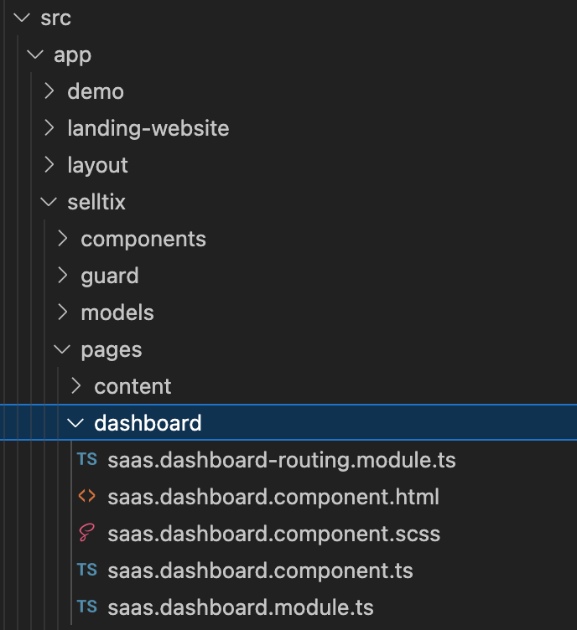

I would like you to mix what I started with their functionalities. We need to discuss about it.

Slide 3: When clicking on an event, we display the event page with all event’s details.

Slide 4: when clicking on plus button “new event” (from slide 2), a popup to create the event, will be shown.
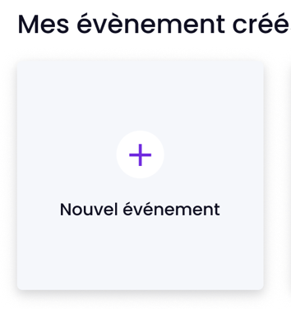

Slide 5: Popup to continue creating the event, with different steps. Please note this should be responsive too.

Slide 6: I’m not sure why they made this, may be it is to show the responsive behaviour…

Slide 7: Payment option while creating the event
Slide 8: Last step of event creation.
Slide 9 to 12 is to show how to create a Ticket. And I think slide 11 is to show the responsive design.

If it’s easier for you to manage, implement only one behaviour (slide 6 & 11) which is working for responsive and non responsive since we don’t have a menu on left side.

Slide 13 : it’s the public event page. I don’t like it and it make no sense since our events are online (so no google maps). Our previous design was : https://www.selltix.live/event/music-conference

May be you can propose us something else…

Slide 14 to 16: Ignore these pages.

Slide 17: Account creation.

Modifications from previous website:

In previous website, we had a popup to edit a ticket and create a personalized design. I have imported the code, but some of the design is broken.
You can test on the dashboard, I added a button : TEST NFT DESIGNER
On click it will open our previous popup:

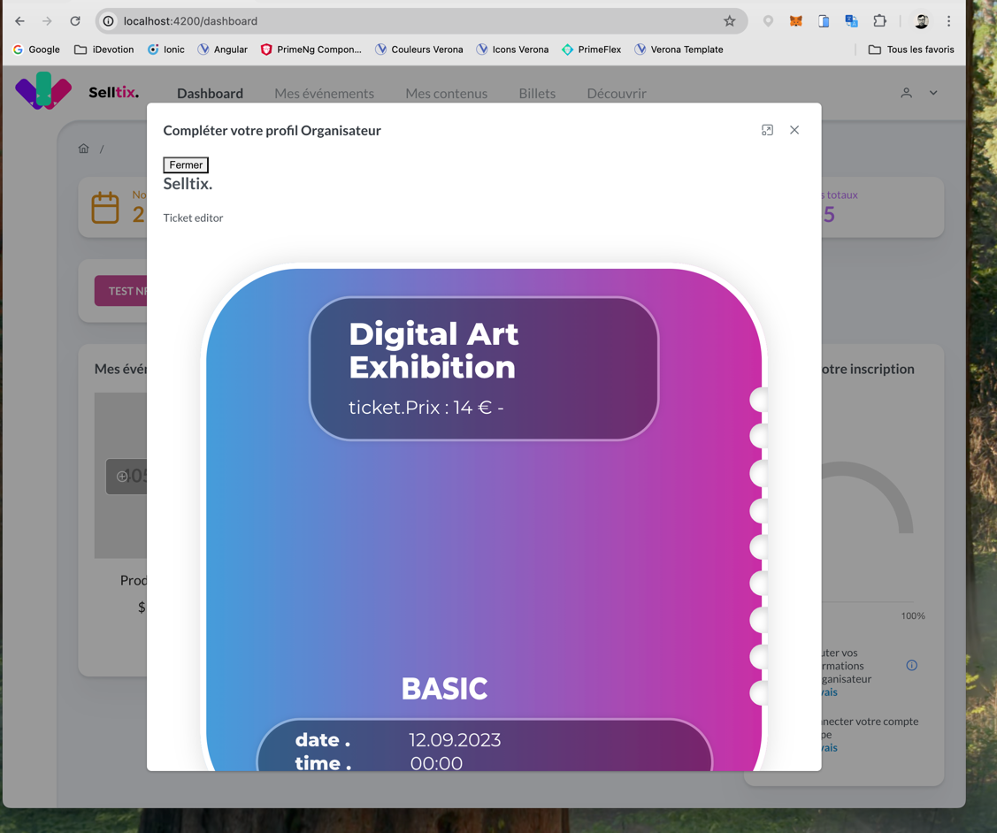

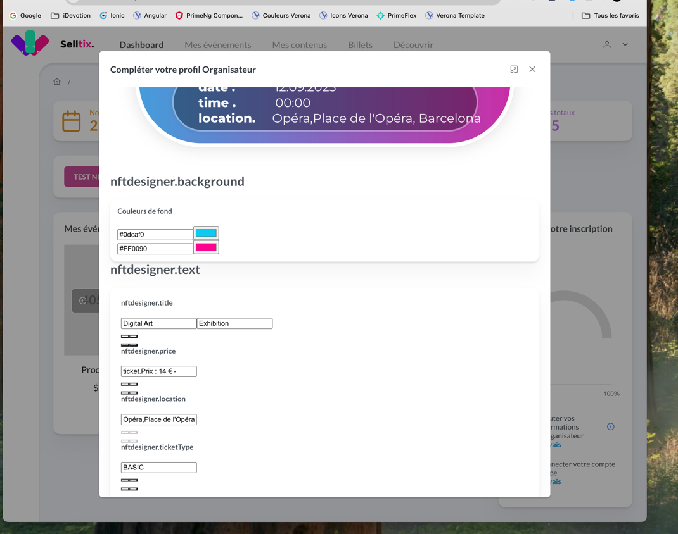
With broken design
Previous design was :

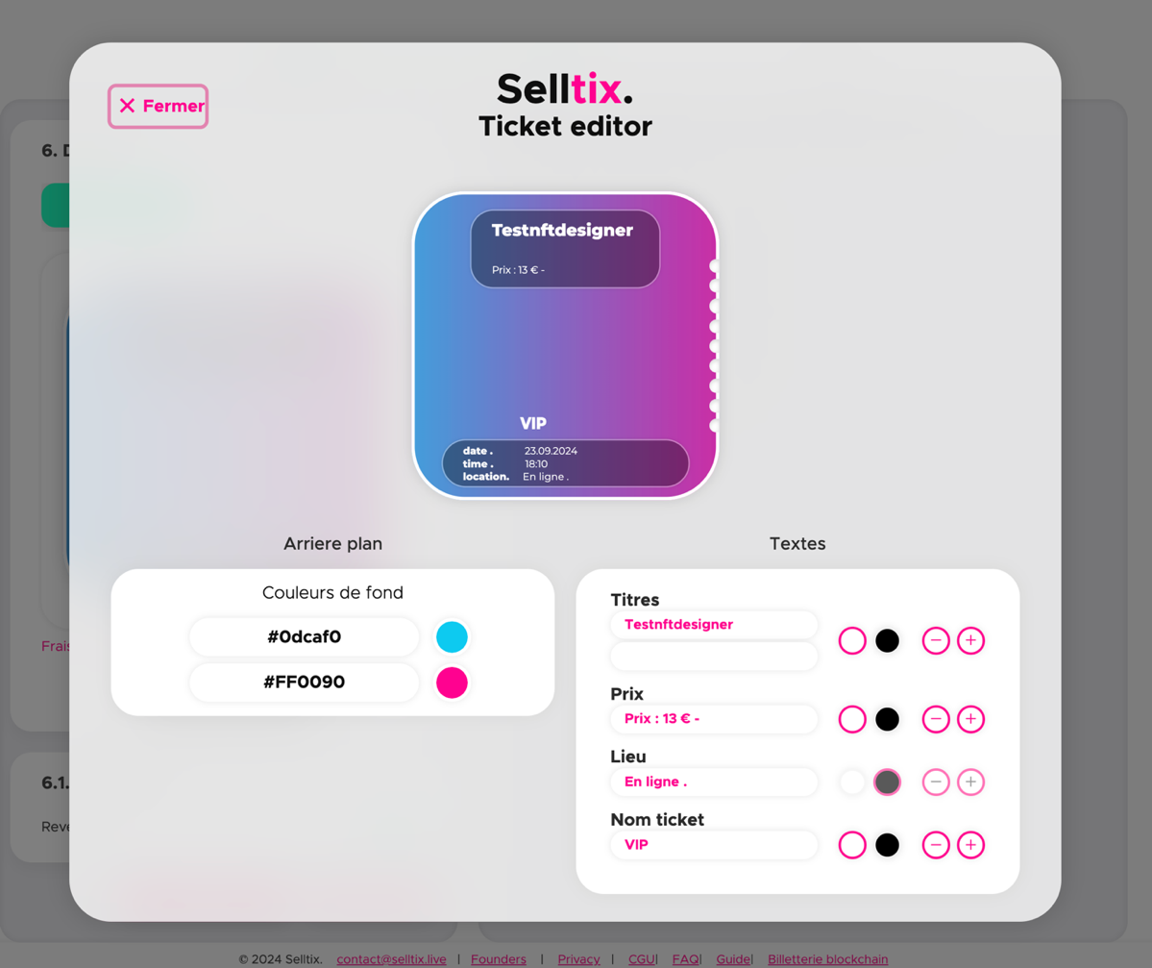

Could you make correction on this popup ? (you can keep the PrimeNg Dialog elements to close the popup). It’s just the content which is not good (size of the SVG tickets and the visual elements).

If you don’t remember, I find your code to adapt the design. It is located in the previous project SellTixLive, in assets/scss/_modal.scss
